Name: Varia Neel Jitesh
Enrollment No: 250447003019

Network Security And Forensics
Lab Session – 3
Perform the depth protocol analysis by Wireshark.
Set up Wireshark to capture packets on a network interface.
- Capture and analyze various types of traffic, such as HTTP, DNS, and FTP.
- Examine packet headers, source and destination IP addresses, port numbers, and protocols.

- Use display filters to focus on specific types of traffic
- Experiment with different display filter expressions.
- Explore and understand color-coded packet markings.

- Analyses the handshake process in
- Investigate DNS query and response packets.
- Examine HTTP requests and responses, including headers and content. Packet Filtering and Display Filters:
- Use Wireshark to capture network traffic in a specific scenario (e.g., browsing a website, downloading a file).
- Apply display filters in Wireshark to isolate specific types of packets (e.g., HTTP, TCP).
- Experiment with different display filters and observe how they affect the captured traffic view.
- How can display filters help in focusing on relevant packets during network analysis?

Capture and analyze various types of traffic, such as HTTP, DNS, and FTP.
HTTP Packets
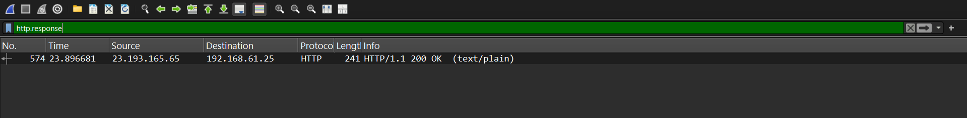

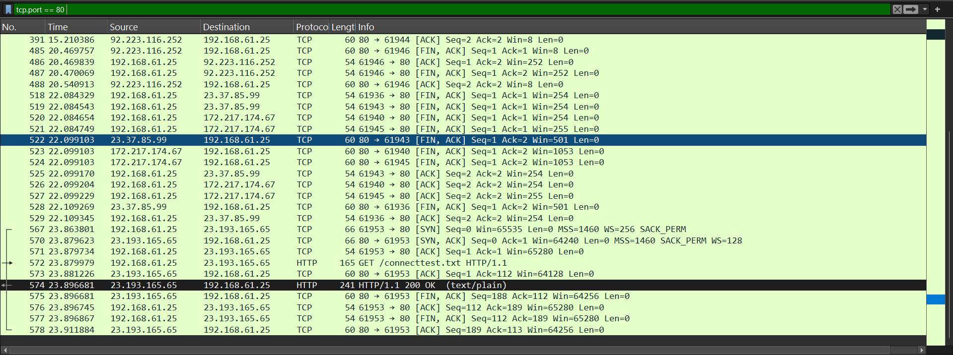
DNS

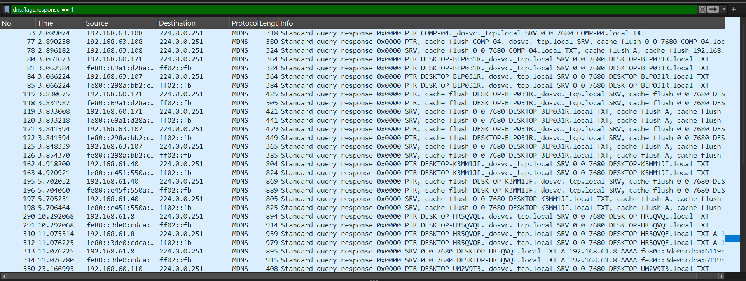

Layer | Header Type | Purpose
Layer 2 | Ethernet Header | MAC addressing
Layer 3 | IP Header | Logical addressing
Layer 4 | TCP / UDP Header | Port numbers, reliability
Layer 7 | Application Header | Protocol-specific data

Packet Headers
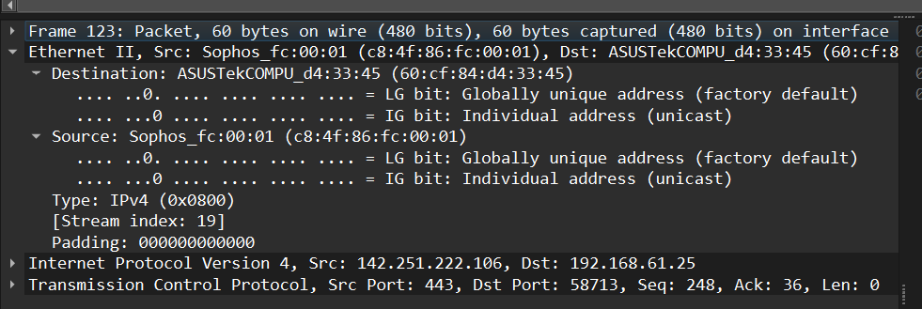

Examining IP Header
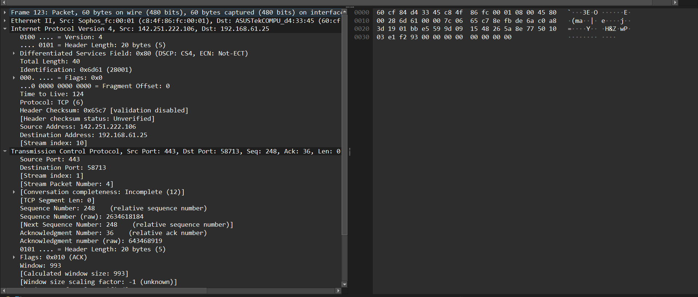

Examining Application Layer Protocols
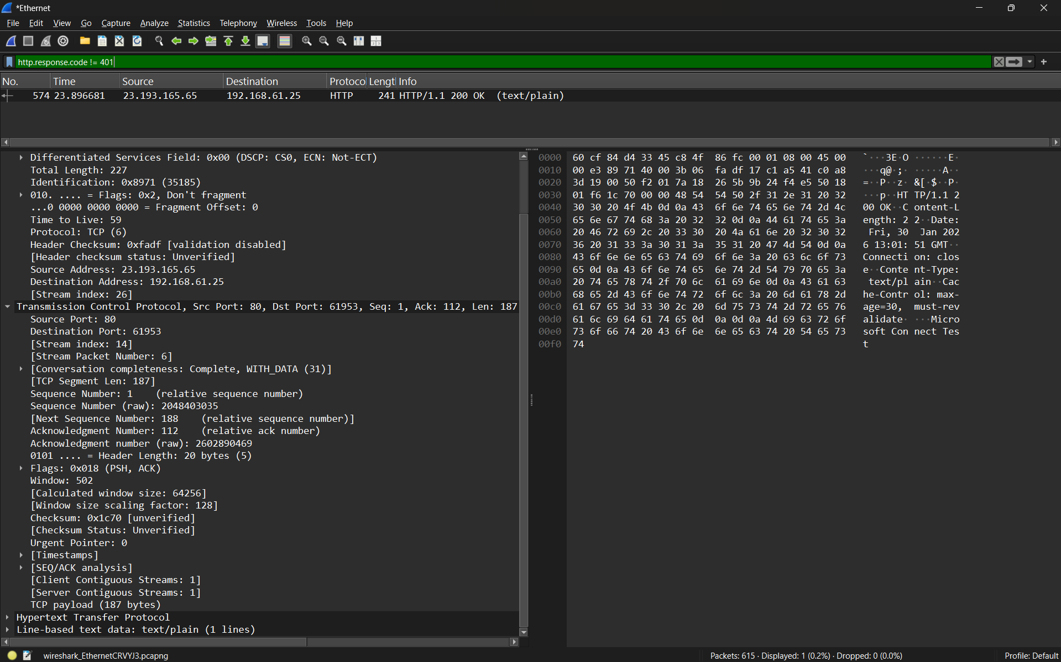

Use display filters to focus on specific types of traffic
Specific HTTP Filters
http.request
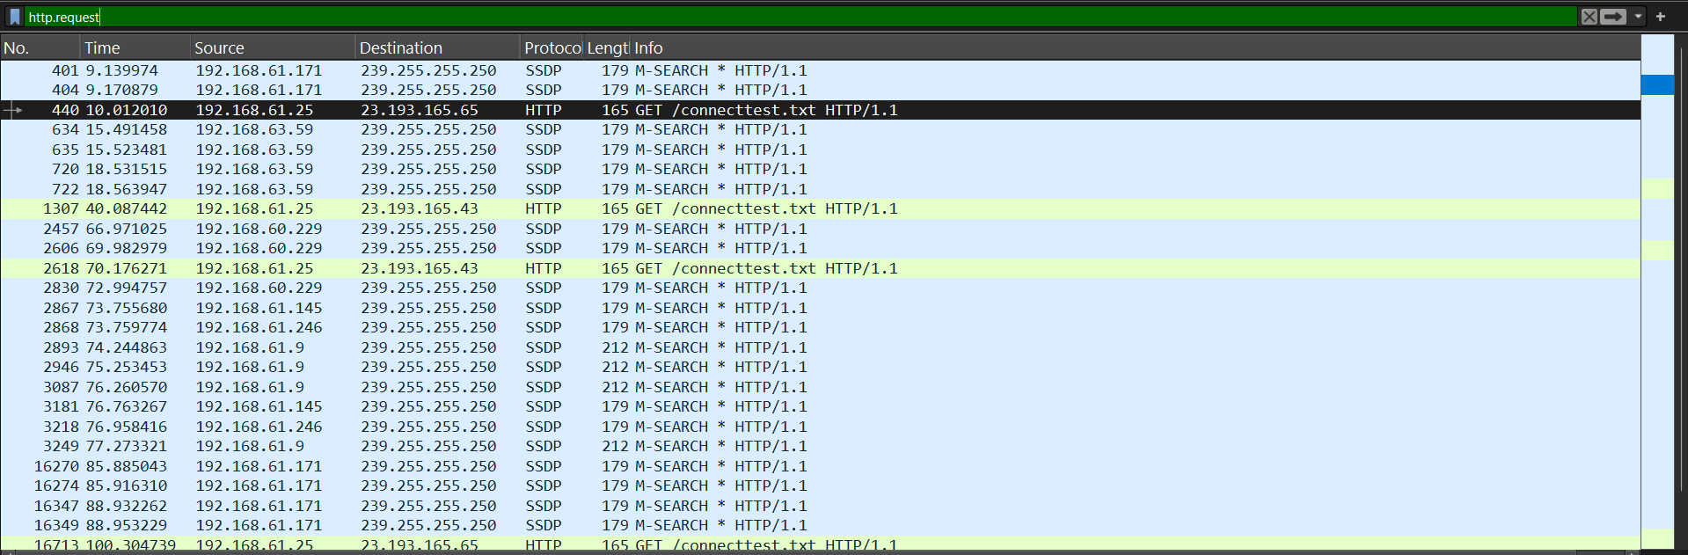

http.response
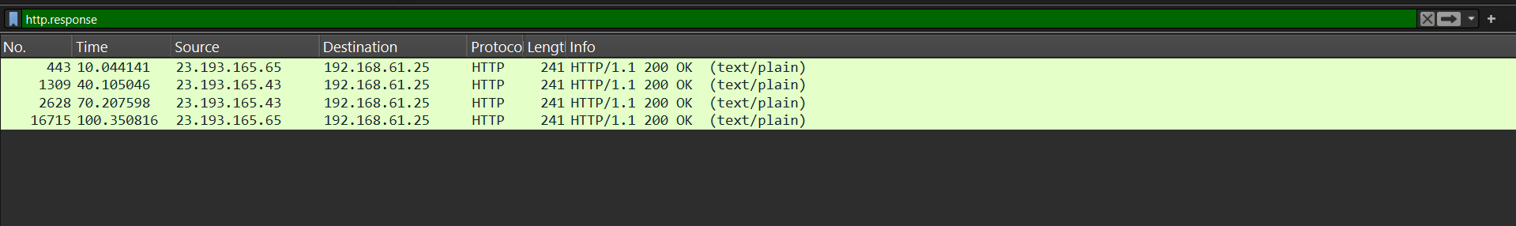

http.request.method == "GET"
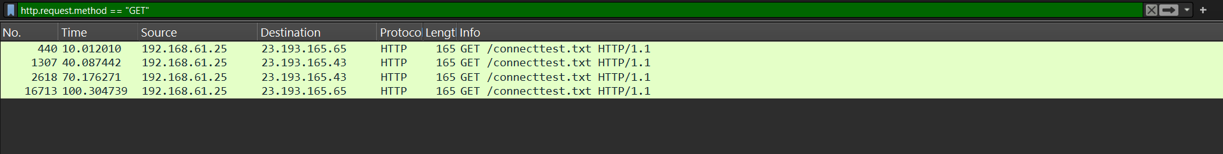
tcp.port == 80
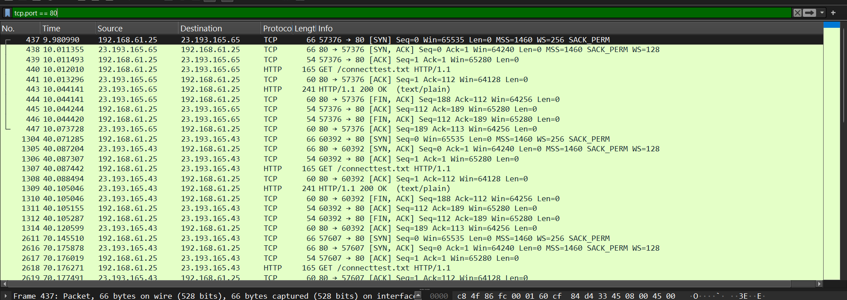
Used to analyze web browsing activity.

udp.port == 53
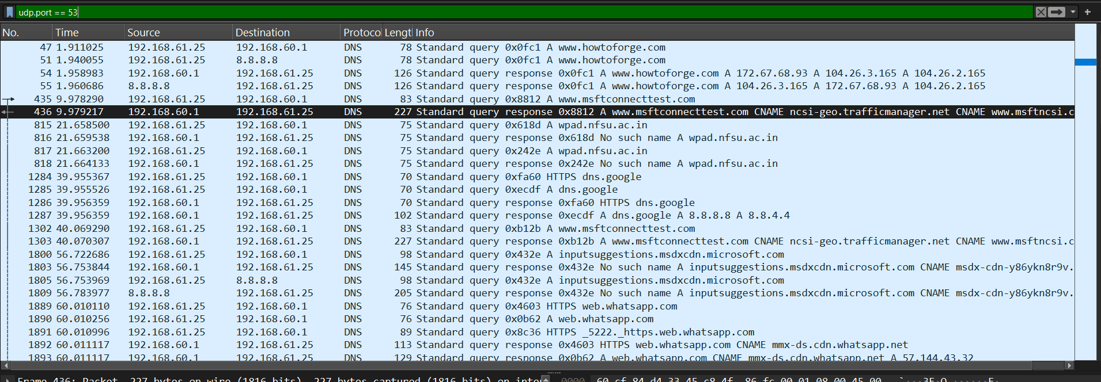
dns.qry.name
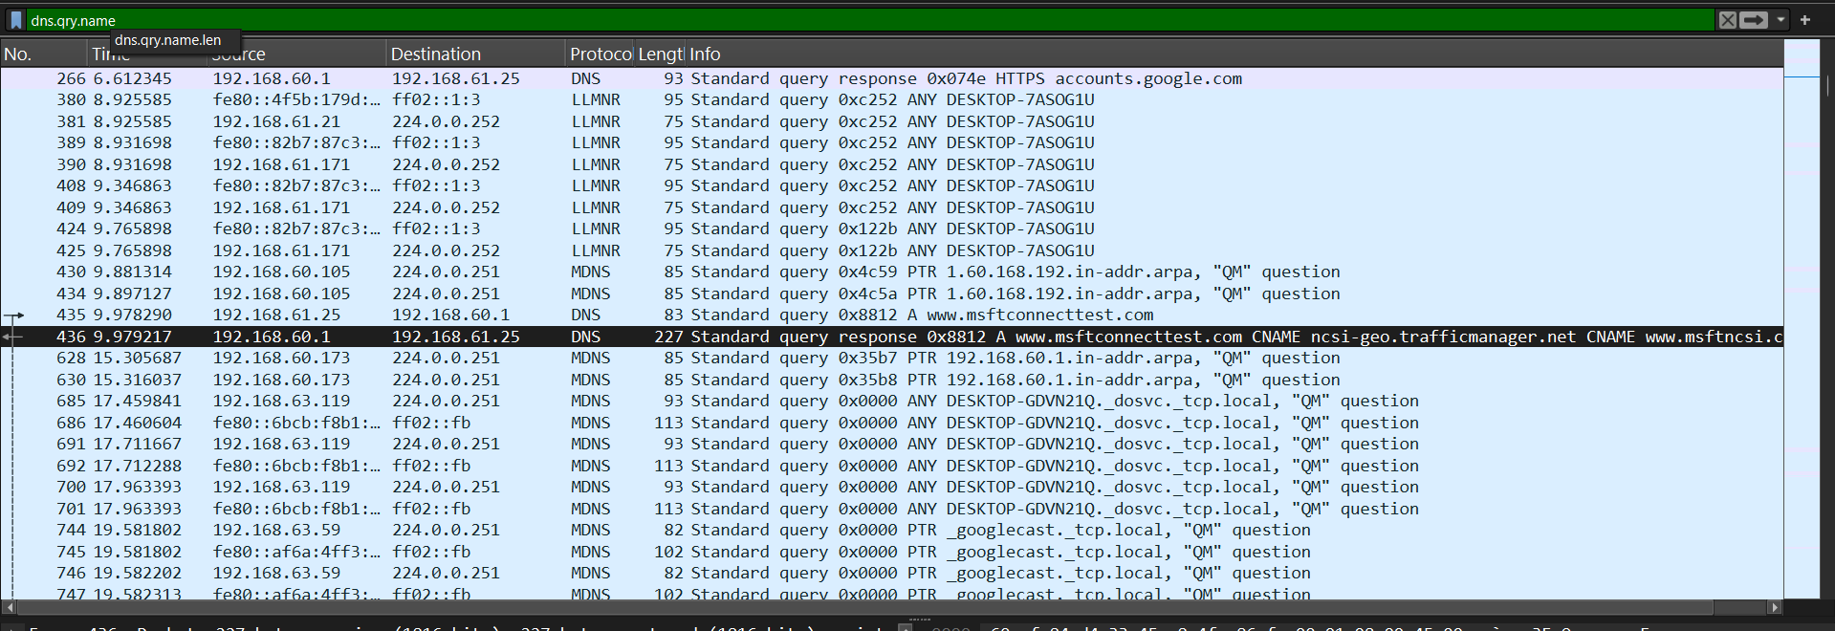
dns.flags.response == 1
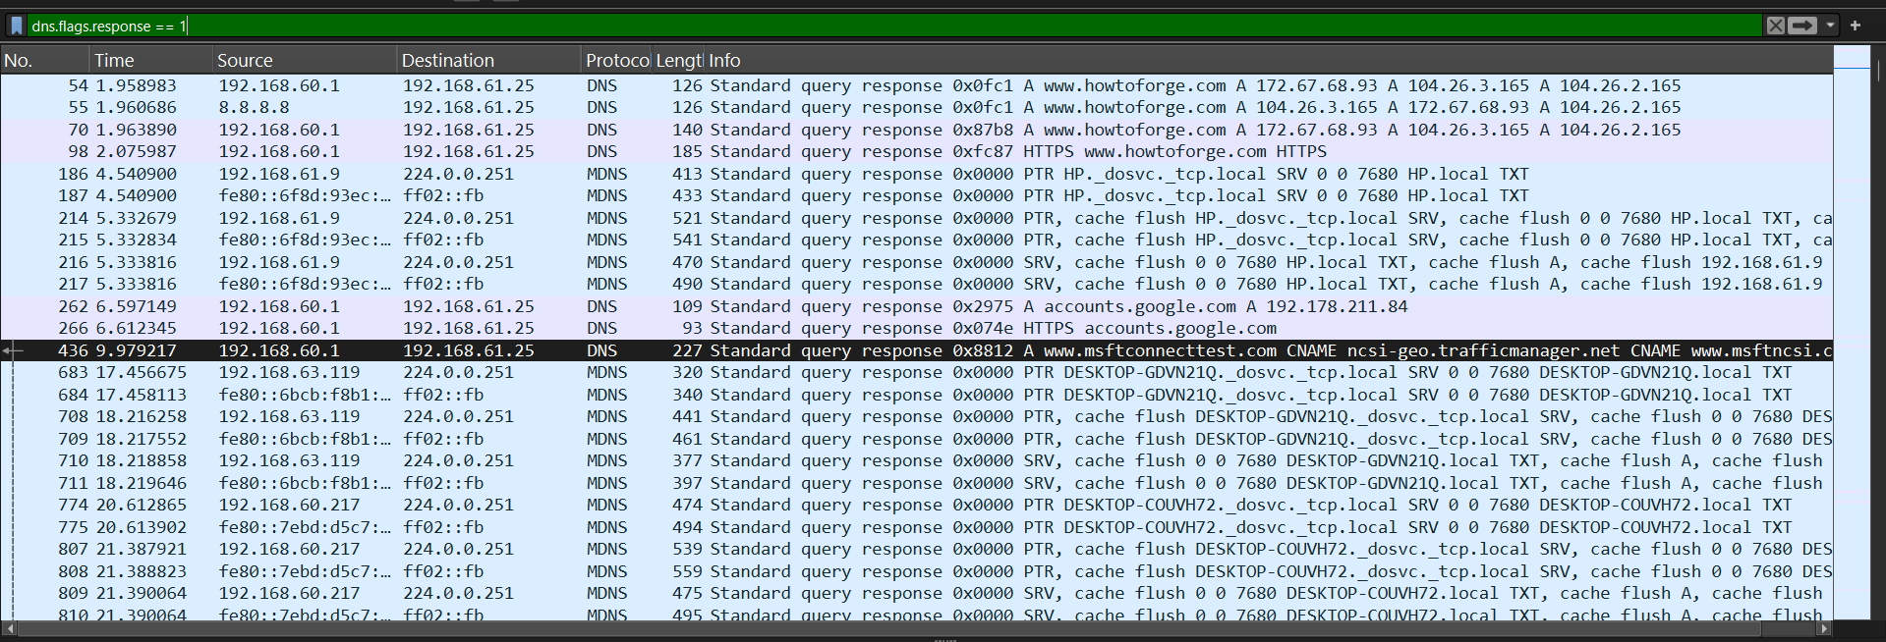

dns && dns.flags.response == 0
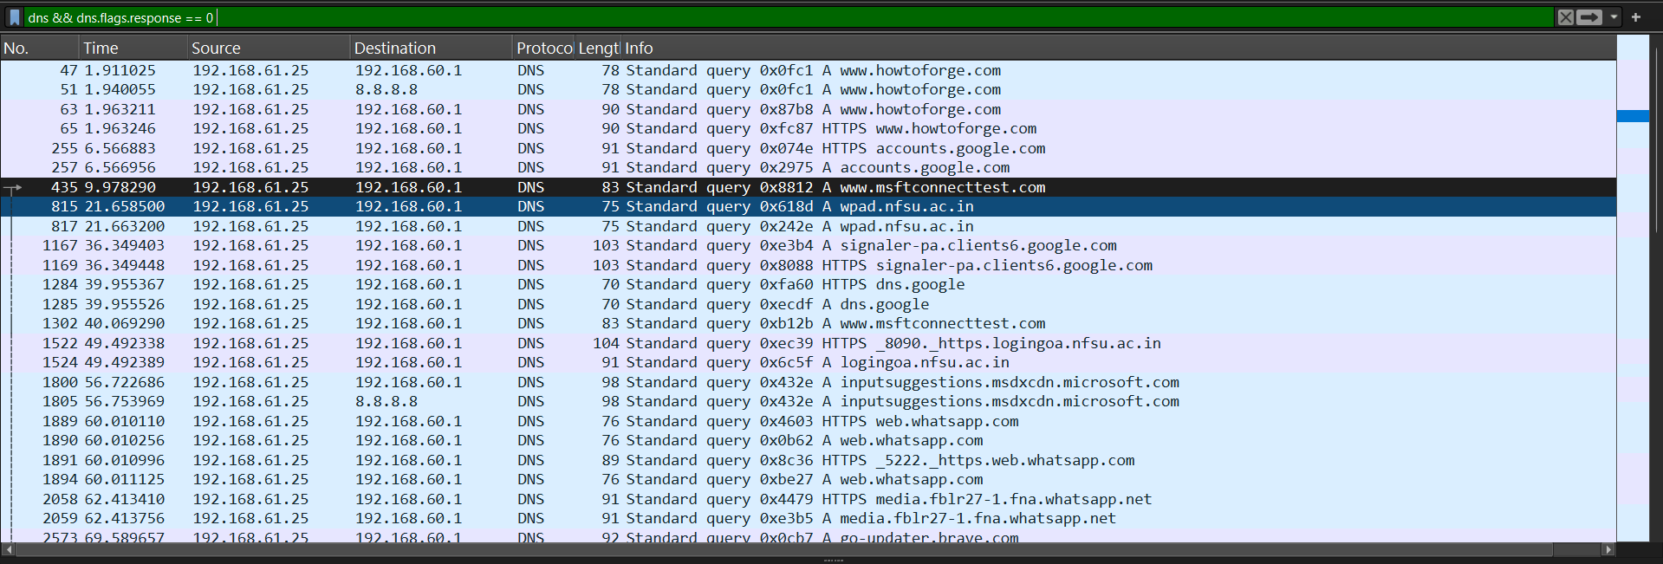

Explore and understand color-coded packet markings.
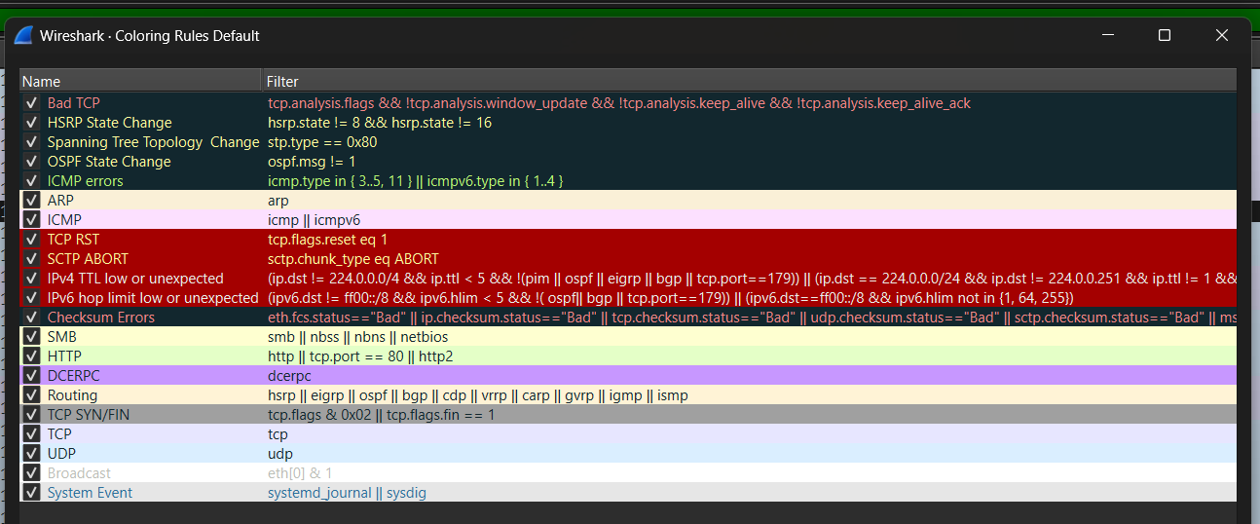

Analyze the handshake process in Wireshark
The TCP three-way handshake is the process used by the Transmission Control Protocol (TCP) to establish a reliable connection between a client and a server before data transfer begins.

Filtering Only Handshake Packets

SYN (Synchronize)
SYN-ACK (Synchronize + Acknowledge)
ACK (Acknowledge)

Only SYN Packets
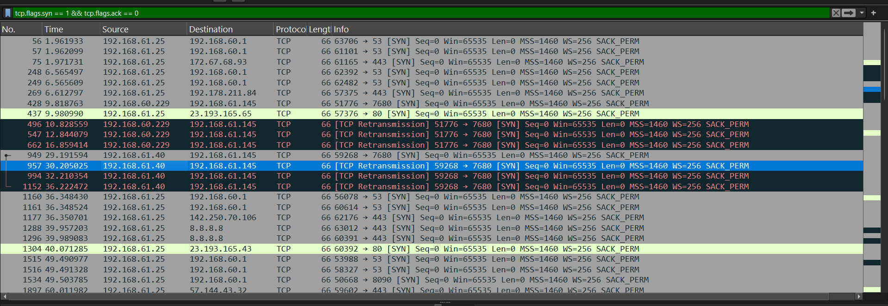

SYN-ACK Packets
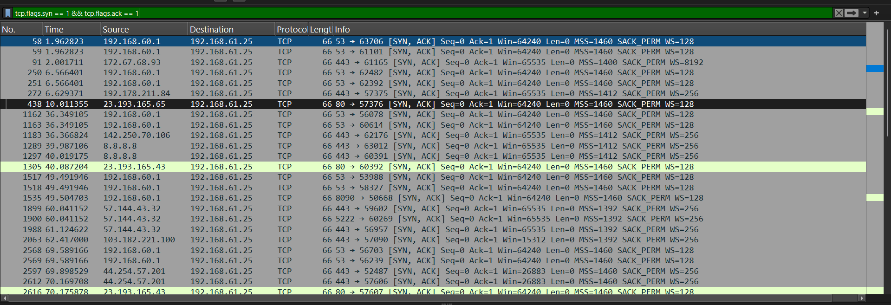
ACK Packets
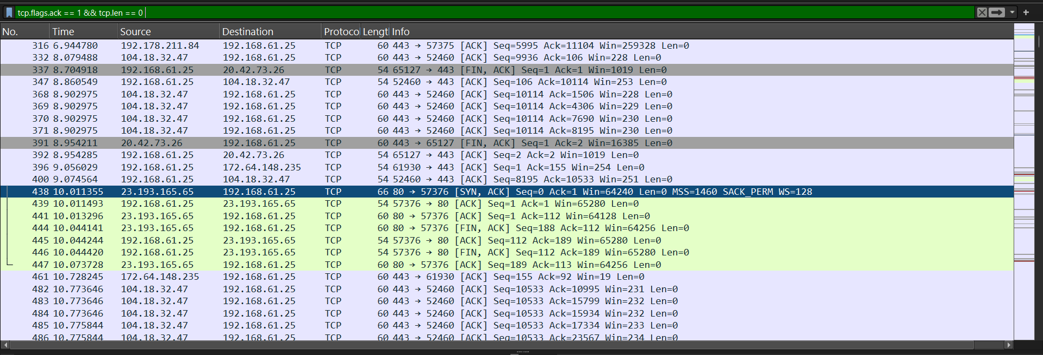

Name: Varia Neel Jitesh
Enrollment No: 250447003019

Network Security And Forensics

Lab Session – 3 – Packet Tracing
1. Use Cisco Packet Tracer tool to design and configure a small network.
Create a network topology with routers, switches, and end devices.
- Assign IP addresses and configure routing protocols (e.g., RIP, OSPF).
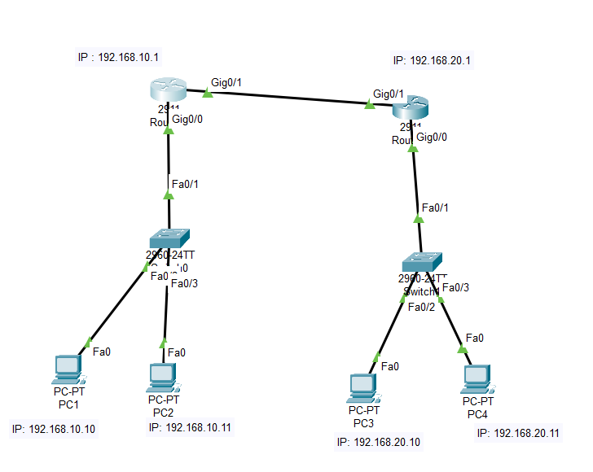

- There are 2 Routers with IP assigned as:
  - Router0- 192.168.10.1 & Router1- 192.168.20.
- There are 2 switches which are connected with routers and further they are connected with the consequently PCs.
- There are 4 PC with IP assigned as: PC1- 192.168.10.10, PC2-192.168.10.11, PC3- 192.168.20.10, PC4- 192.168.20.11

Simulate traffic between devices and analyze packet flow.
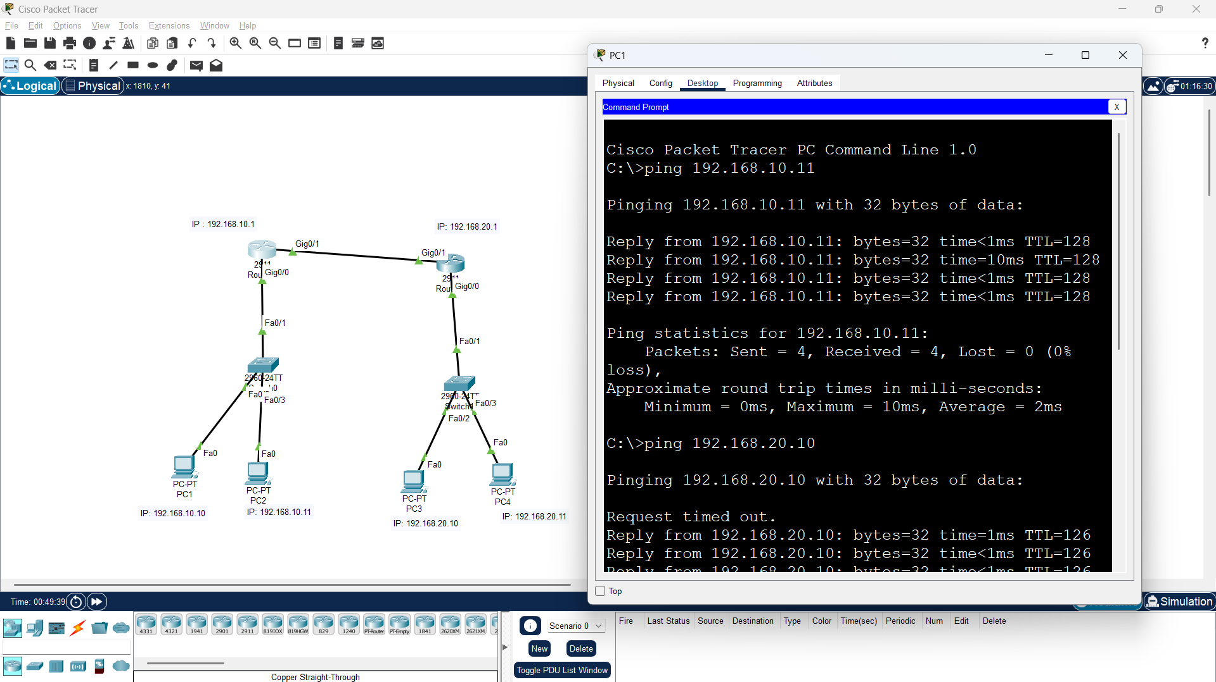

For Routing RIP version 2 protocol is being used to connect both the router with each to make a connection with the Copper Straight-Through wire cable to join the devices with each other.
Now as the connection is successfully established the ping pc2, pc3 and pc4 is showing the results

The packet flow from the PC1 to PC3 goes in this flow:
PC1 → Switch0 → Router0 → Router1 → Switch1 → PC3

Implement basic firewall rules and observe their effect.
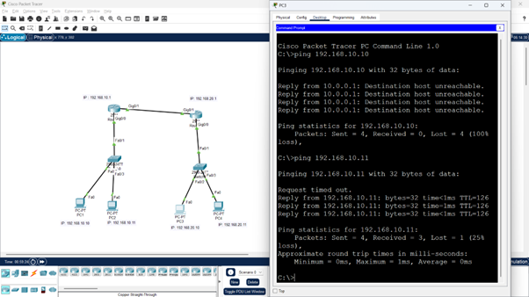
Now From the image, firewall is being Established which is blocking the traffic from PC3 and allowing all the other traffic data coming to PC1.
Whenever the traffic is coming from PC3 with the IP address 192.168.10.10 it is showing “Destination unreachable”, instead of which whenever the data is coming from any other ping like 192.168.10.11 it is showing success.
It shows that the firewall is being created and is active for the data traffic coming from ping 192.168.10.11 into pc3 is being blocked while for all the other ip addresses it is allowed.

